Object Storage with Amazon S3
- Standalone storage: Amazon S3 is not tied to compute, unlike Amazon EBS.
- Accessible anywhere: Data in S3 can be retrieved from anywhere on the web.
- Similar to online backup services: Functions like cloud backup services but with object storage.
- Object storage:
  - Stores data in a flat structure rather than a file hierarchy.
  - Each object consists of a file plus metadata.
  - Supports storing unlimited objects.
- Characteristics: Amazon S3 inherits all standard object storage features.
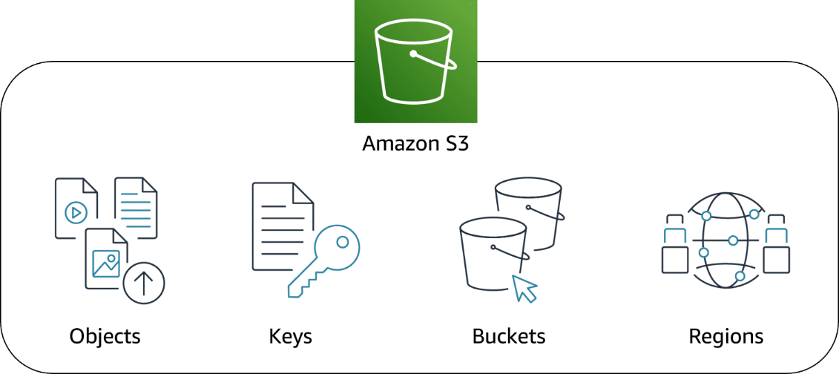
- Buckets: Amazon S3 stores objects in containers called buckets.
- Bucket requirement: You must create a bucket before uploading any object.
- Object identification: Each object is uniquely identified by a combination of bucket name, key, and version ID.
- Bucket creation details: When creating a bucket, you must specify at least:
  - Bucket name and AWS Region where the bucket will reside
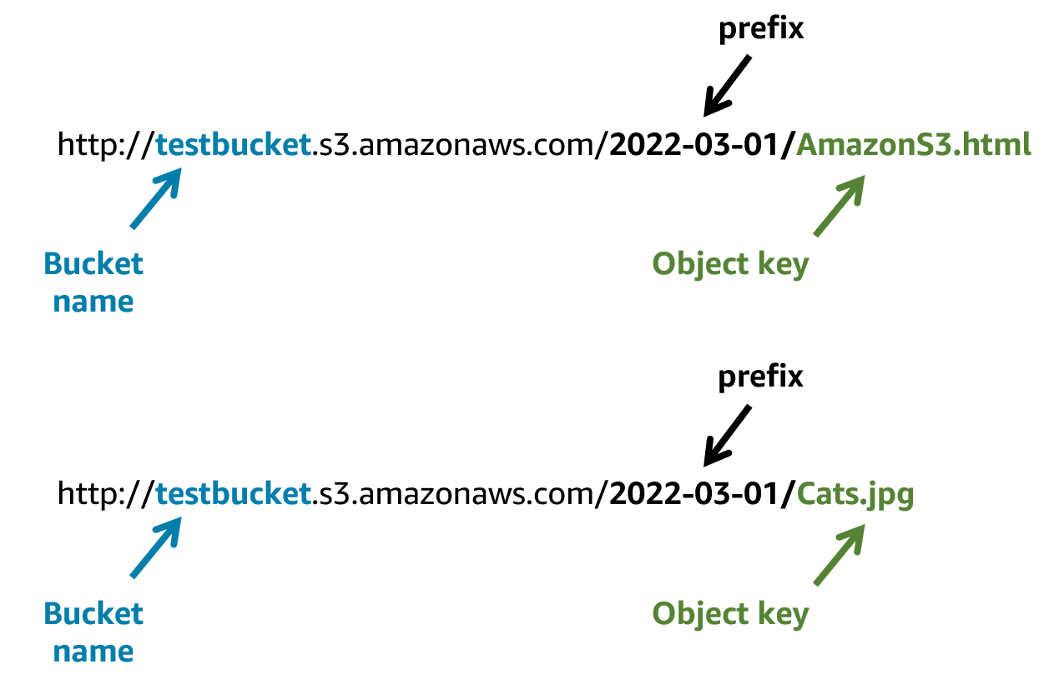

Amazon S3 and IAM policies
- IAM policies with S3: Policies define which actions users, groups, roles, or resources can perform on S3 buckets and objects.
- Policy types:
  - Resource-based policies: Attached directly to buckets or objects.
  - User policies: Attached to IAM users, groups, or roles.
- When to use IAM policies for private buckets:
- Multiple buckets with different permissions: Centralizes control instead of creating many bucket-specific policies.
- Centralized policy management: All policies can be managed in one location.

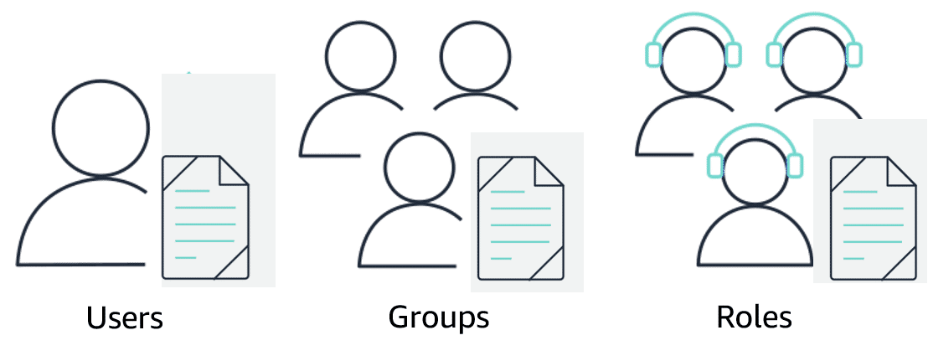
Amazon S3 bucket policies
- S3 bucket policies:
  - Defined in JSON format, similar to IAM policies.
  - Can only be attached to S3 buckets, not users or roles.
  - Apply to all objects within the bucket.
  - Specify allowed or denied actions on the bucket.
- When to use S3 bucket policies:
  - To enable cross-account access to S3 without using IAM roles.
  - When IAM policies reach their size limit, since bucket policies allow larger sizes.
S3 Encryption
- Encryption in transit and at rest: Amazon S3 protects data both while moving and when stored.
- Automatic encryption: All objects are automatically encrypted upon upload.
- Server-side encryption: Uses S3-managed keys (SSE-S3) as the default encryption for every bucket.
- No additional cost: Encryption is applied automatically at no extra charge.

Storage classes
- S3 standard: Amazon S3 is considered general-purpose storage.
Applications include Cloud applications, Dynamic websites
Content distribution, Mobile and gaming applications
Big data analytics

- S3 Intelligent-Tiering- Designed for data with unknown or changing access patterns.
- Three tiers:
Frequent Access Tier
Infrequent Access Tier
Archive Instant Access Tier
S3 monitors data access patterns and moves objects to the most cost-effective tier automatically.
- S3 Standard-Infrequent Access (S3 Standard-IA)
- Designed for less frequently accessed data that still requires rapid access.
- Offers high durability, high throughput, and low latency similar to S3 Standard.
- Lower per-GB storage cost with an additional per-GB retrieval fee.
- Ideal for long-term backups, disaster recovery files, and other infrequently accessed data.
- S3 One Zone-Infrequent Access (S3 One Zone-IA)
- S3 Glacier Instant Retrieval
- S3 Glacier Flexible Retrieval
- S3 Glacier Deep Archive
- S3 on Outposts

S3 versioning
- Object Naming in S3: Amazon S3 identifies objects using their names (e.g., employee.jpg in a bucket called employees).
- Overwrite Issue: Without versioning, uploading an object with the same name overwrites the existing object.

- Problems with Overwriting:
  - Common Names: Objects with common names may be unintentionally overwritten, making the original inaccessible.
  - Version Preservation: Maintaining multiple versions requires manually renaming objects, which can create clutter and confusion.
- Solution – S3 Versioning:
- Keeps multiple versions of the same object in a bucket.
- Allows recovery from accidental deletion, overwrites, or application failures.
- Eliminates the need to use different names for each version.

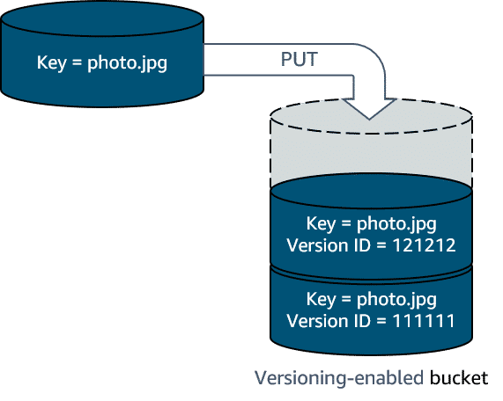
- Version IDs: When versioning is enabled, S3 assigns a unique version ID to each object.
- Example: employeephoto.jpg can have multiple versions like version 111111 and version 121212.
- Recovery from Deletion or Overwrite:
  - Deleting an Object: S3 adds a delete marker instead of permanently removing the object; removing the marker restores the object.
  - Overwriting an Object: Creates a new version while keeping previous versions accessible.
Versioning states
- Unversioned - No new and existing objects in the bucket have a version.
- Versioning enabled
- Versioning suspended

Managing your storage lifecycle
Manually changing object storage tiers (like employee photos) can be automated using Amazon S3 Lifecycle.
Lifecycle configuration allows you to automate actions for objects.
Two main actions you can automate are:
- Transition – move objects between storage tiers.
- Expiration – delete objects after a set time.
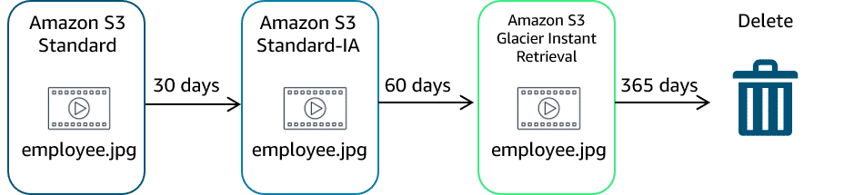
Resources
(opens in a new tab)
For more information, see the following resources:
- AWS website: Amazon S3(opens in a new tab)
- AWS website: Amazon S3 Storage Classes(opens in a new tab)
- AWS user guide: Using Versioning in S3 Buckets(opens in a new tab)
- AWS user guide: Bucket Naming Rules(opens in a new tab)
- AWS user guide: Bucket Policy Examples

